Name: Abhishek Patil Class: CSAIML-A PRN: 12414243 Roll No.: 08

ASSIGNMENT: 4

- Check if a Number is a Palindrome
Algorithm:
- Start
- Input num
- Set original = num, reverse = 0
- Repeat while num > 0
- Get last digit: digit = num % 10
- reverse = reverse * 10 + digit
- num = num / 10
- If original == reverse → Print "Palindrome"
- Else → Print "Not a palindrome"
- End

Code:
#include <stdio.h>

int main() {
int num, original, reverse = 0, digit;
printf("Enter a number: ");
scanf("%d", &num);
original = num;

while(num > 0) {
digit = num % 10;
reverse = reverse * 10 + digit;
num /= 10;
}

if(original == reverse)
printf("Palindrome\n");
else
printf("Not a palindrome\n");

return 0;
}

Flowchart:

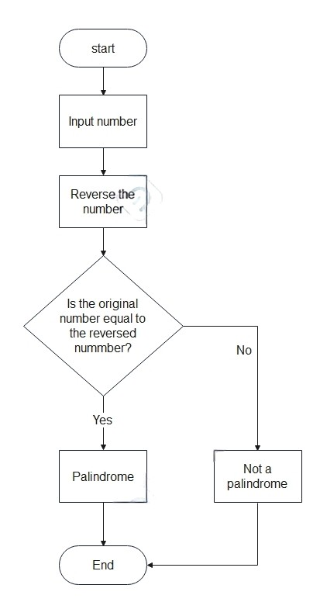
- Sum of All Prime Numbers from 1 to n
Algorithm:
- Start
- Input n, initialize sum = 0
- For i = 2 to n:
- Set isPrime = 1
- For j = 2 to i / 2
  - If i % j == 0 → Set isPrime = 0 and break
- If isPrime == 1 → sum+=1
- Print sum
- End

Code:
#include <stdio.h>

int main() {
int n, i, j, isPrime, sum = 0;
printf("Enter the value of n: ");
scanf("%d", &n);

for(i = 2; i <= n; i++) {
isPrime = 1;
for(j = 2; j <= i / 2; j++) {
if(i % j == 0) {
isPrime = 0;
break;
}
}
if(isPrime)
sum += i;
}

printf("Sum of prime numbers = %d\n", sum);
return 0;
}

Flowchart:

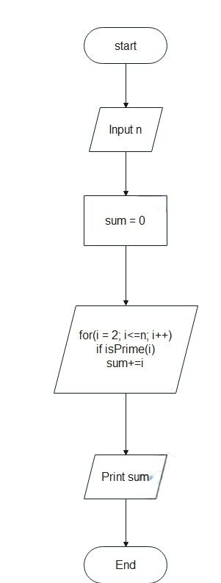

- Check for a Perfect Number
Algorithm:
- Start
- Input num, initialize sum = 0
- For i = 1 to num / 2
- If num % i == 0 → sum += i
- If sum == num → Print "Perfect number"
- Else → Print "Not a perfect number"
- End

Code:
#include <stdio.h>

int main() {
int num, i, sum = 0;
printf("Enter a number: ");
scanf("%d", &num);

for(i = 1; i <= num / 2; i++) {
if(num % i == 0)
sum += i;
}

if(sum == num)
printf("Perfect number\n");
else
printf("Not a perfect number\n");

return 0;
}

Flowchart:
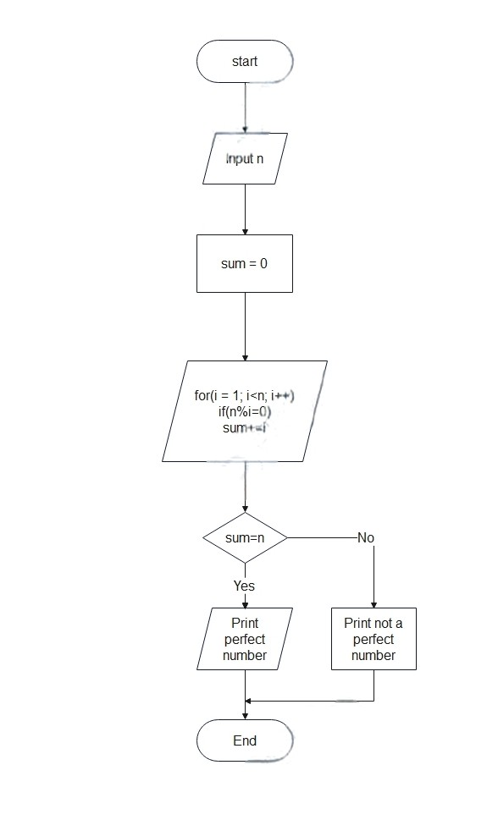

- Fibonacci Series up to n Terms
Algorithm:
- Start
- Input n
- Initialize: a = 0, b = 1
- For i = 1 to n
  - Print a
  - next = a + b
  - a = b, b = next
- End

Code:
#include <stdio.h>

int main() {
int n, i, a = 0, b = 1, next;
printf("Enter number of terms: ");
scanf("%d", &n);

for(i = 1; i <= n; i++) {
printf("%d ", a);
next = a + b;
a = b;
b = next;
}
return 0;
}

Flowchart:

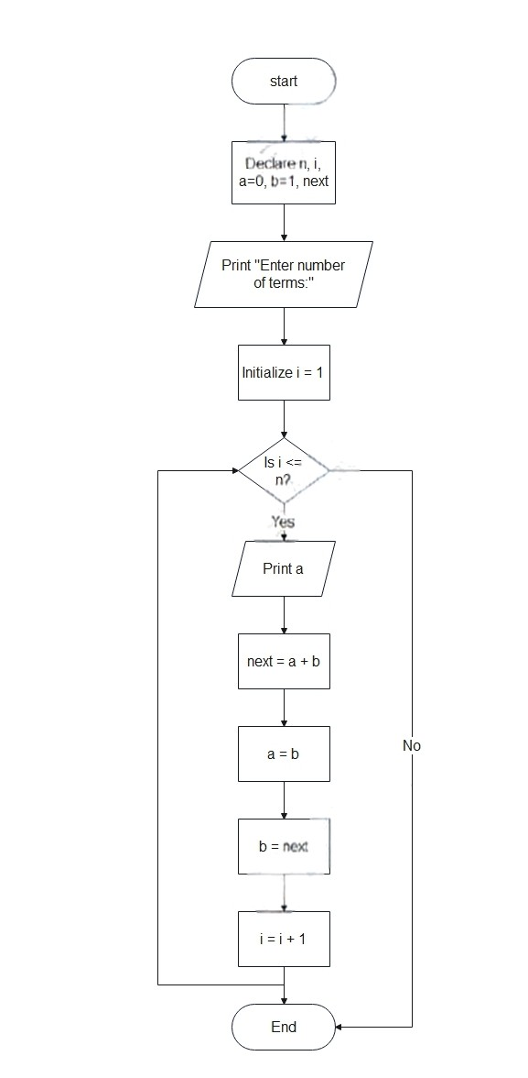

- Armstrong Numbers between 1 to n
Algorithm:
- Start
- Input n
- For i = 1 to n
  - Set num = i, sum = 0, count = 0, temp = num
  - Count digits:
    - While temp > 0 → count++, temp /= 10
  - Set temp = num
  - While temp > 0
    - digit = temp % 10
    - sum += pow(digit, count)
  - temp /= 10
  - If sum == num → Print num
- End

Code:
#include <stdio.h>
#include <math.h>

int main() {
int n, i, num, temp, sum, digit, count;

printf("Enter the value of n: ");
scanf("%d", &n);

for(i = 1; i <= n; i++) {
num = i;
temp = num;
count = 0;
sum = 0;

while(temp > 0) {
temp /= 10;
count++;
}

temp = num;
while(temp > 0) {
digit = temp % 10;
sum += pow(digit, count);
temp /= 10;
}

if(sum == num)
printf("%d ", num);
}

return 0;
}

Flowchart:
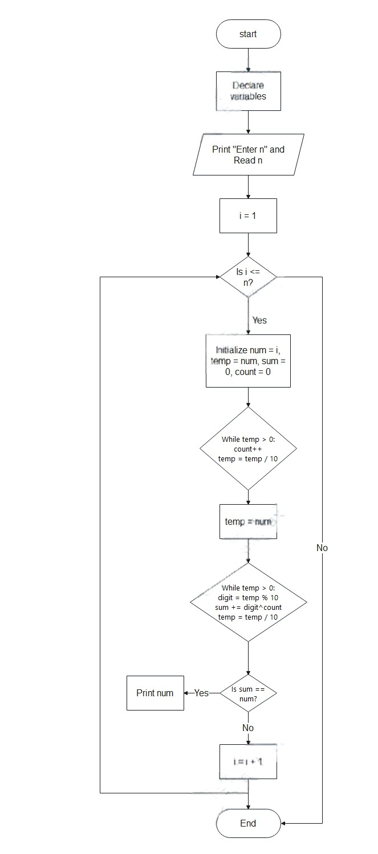
- Triangle Pattern of Prime Numbers
Algorithm:
- Start
- Input n
- For i = 1 to n:
  - Get start = ith prime
  - For j = 1 to i:
    - Print start
    - start = next prime of start
- End

Code:
#include <stdio.h>

int isPrime(int num) {
if(num < 2) return 0;
for(int i = 2; i <= num/2; i++)
if(num % i == 0)
return 0;
return 1;
}

int nextPrime(int current) {
int next = current + 1;
while(!isPrime(next))
next++;
return next;
}

int nthPrime(int n) {
int count = 0, num = 1;
while(count < n) {
num++;
if(isPrime(num))
count++;
}
return num;
}

int main() {
int n, i, j;
printf("Enter the number of rows: ");
scanf("%d", &n);

for(i = 1; i <= n; i++) {
int prime = nthPrime(i);
for(j = 1; j <= i; j++) {
printf("%d ", prime);
prime = nextPrime(prime);
}
printf("\n");
}

return 0;
}

Flowchart:
